
Solution Architecture

Date | 15 july 2026
Team ID
Project Name | Voice Based Concept Understanding Analyser
Maximum Marks | 5 Marks

Solution Architecture Diagram:
A high-level representation of the system architecture is shown below, divided into Presentation Layer, Application Layer, and Data Layer.
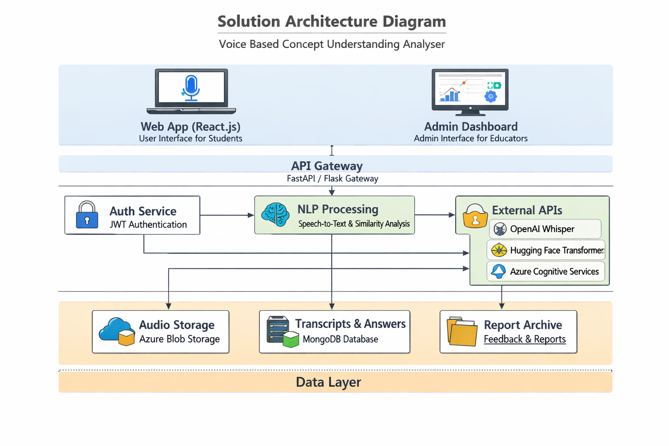


Component Description Table

Component Name | Description / Role in Architecture | Technologies Used
Presentation Layer | Provides user interface for recording/uploading audio and viewing feedback reports. | React.js, HTML, CSS, Bootstrap
API Gateway | Manages request routing between frontend and backend services. | FastAPI / Flask
Microservices | Handles speech-to-text, NLP preprocessing, similarity scoring, and feedback generation. | Python, Whisper API, HuggingFace Transformers
Database | Stores audio, transcripts, reference answers, and feedback reports. | MongoDB, Azure Blob Storage

